**Linear Functions 2 7/7**

Directions: FInd the slope of each line

(y2-y1)

_______________________

(x2-x1)

1) 2) 3)

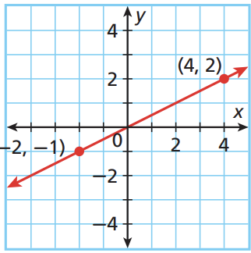 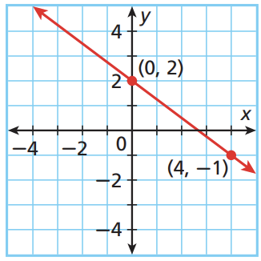 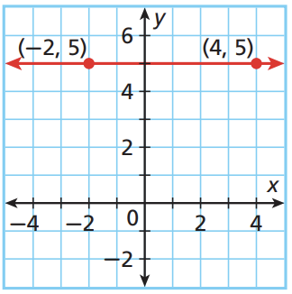

4)

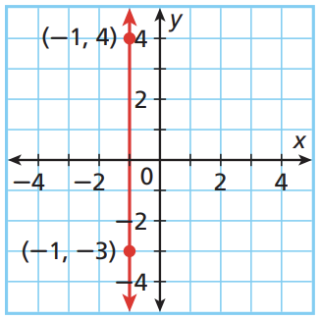

5) Plot the points (-3, -3) and (1,4), connecting them with a straight line. How can you tell if the point (103, 157) lies on this line? Is this point on the line?

6) Graph the line described by each equation:

a) y - 4 = -1/2(x + 3) b) y + 2 = 3/5(x - 1) c) y - 0 = 4(x - 1)